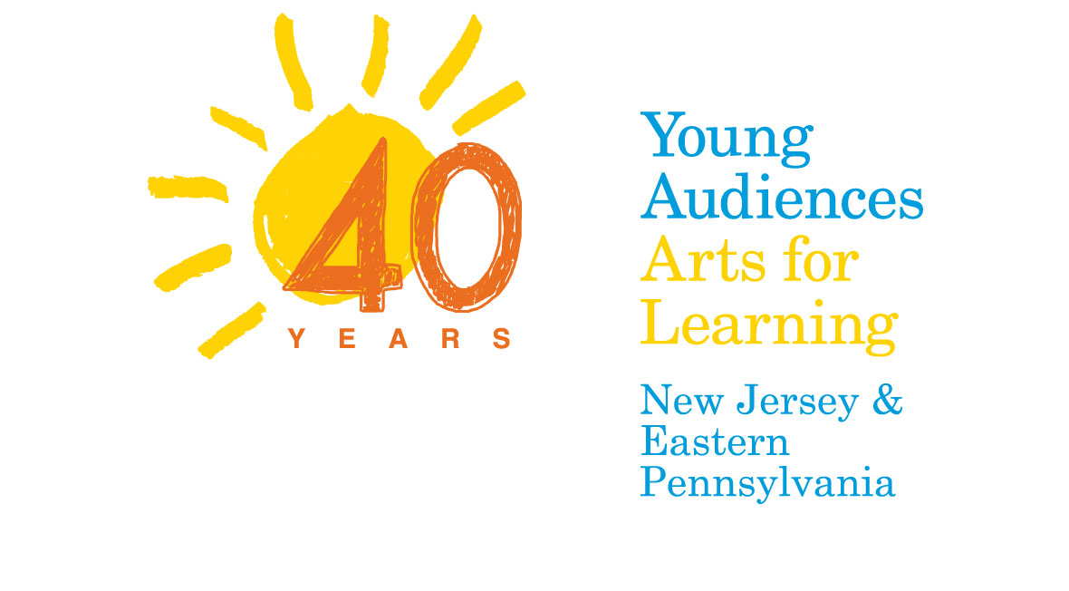
Sandy Relief Arts Education Grants
for NJ schools affected by Hurricane Sandy

Young Audiences New Jersey & Eastern Pennsylvania (YA) is pleased to announce a new initiative to aid schools serving students affected by Hurricane Sandy. The Sandy Relief Arts Education Initiative is a grant program funded through the New Jersey Recovery Fund and YA fundraising efforts that focuses on the power of the arts as a vehicle for healing and recovery, and will offer grants of up to $10,000 to bring arts education programming to schools serving students affected by Hurricane Sandy in New Jersey.

YA will work closely with your school to develop arts programming that meets students’ recovery needs. YA staff will draw from our wide range of programs – school-day, afterschool and evening family programming – to aid each school community in its recovery process. With this grant we hope to strengthen children’s identities and their bonds within their school communities, help them build relationships and gain trust, and enhance children’s self-esteem, confidence and creativity.

The goals of the Young Audiences Sandy Relief Arts Education Initiative are to:
1. Provide arts experiences for children, their teachers and families that focus on healing;
2. Offer arts-based opportunities that aid schools in the recovery process;
3. Provide temporary replacement of arts-integrated programming that was lost.
Your school will work closely with a YA staff member and our professional teaching artists to plan your school’s performance and long-term artist-in-residence program based on your specific needs.
Questions about the Sandy Relief Arts Education Initiative and Grants? Call Liz Winter-Kuwornu at 866-500-9265.

What Your School Gets:

Experiences YA can provide may include:
- An arts education project valued at up to $10,000 that includes approximately 12-15 artist days in your school.
- The guidance and support of YA staff to help assess your needs and plan your YA arts programs.
- An in-depth, hands-on artist-in-residence program focused on healing through the arts, a performance for your entire school and professional development session(s) to help teachers make curricular connections to the arts in their classrooms.
- Assistance in creating a community event to share students’ work and to celebrate your school’s commitment to arts education as an essential part of learning.

What Your School Gives:
- Your school will assemble a team to support this program that includes your principal, at least one teacher (who will be the point person for the project), a parent liaison and a guidance counselor or other school social worker.
- With assistance from YA, your school will publicize the grant award and information about the programs to parents and the local press.
- Your school will assist YA with documentation which will include completing a final report, taking photos and/or videos that YA can use for publicity and appropriate student evaluation of the experience.

Eligibility and Criteria:
To be eligible a school must be:
- Located in one of the school districts (or a charter or private school within the immediate area of that district) most heavily impacted by Sandy.
- Able to assemble a team to support this program that includes your principal, at least one teacher/project coordinator, a parent liaison and a guidance counselor or other school social worker.
- A public, charter or private school (preschool through 12th grade).
Grants are awarded on a competitive basis and evaluated on:
- School’s commitment and desire to provide healing arts programs to its students, teachers and community.
- Demonstrated need.

Additional Information:
- The Project Coordinator listed on the application will receive an email confirmation within 48 hours to confirm receipt of your application.
- Winning applicants will be notified via phone or email if your school is selected.
- Planning with Young Audiences’ staff will occur at the start of the school year.

Sandy Relief Arts Education Initiative Application, page 1

How to Apply:
- Complete the application by typing in the fields provided (or on a separate sheet).
- Print the application.
- Sign the application (Principal, Project Coordinator and Parent Liaison Signatures are required).
- Scan to PDF and return it to Young Audiences via email to lwinter@yanj.org
or fax to 609-243-8999. For more information call Liz Winter-Kuwornu at 866-500-9265.

Name of School
Address
City
State
Zip
Phone
Fax
Number of Students
Grade Levels Served

Required Signatures—please sign, scan and include in your application.
Principal Signature
Principal Name
Principal Email
Project Coordinator Signature
Project Coordinator Name
Project Coordinator Title
Project Coordinator Email
Parent Liaison Signature
Parent Liaison Name
Parent Liaison Email

Sandy Relief Arts Education Initiative Application, page 2

Please answer the following questions adding no more than three pages (add separate pages as necessary):

- Please explain how your school and school community (students, teachers, staff) was affected by Hurricane Sandy.

- How do you feel arts programming can help meet your student’s recovery needs?

- Describe your school’s and school community’s current situation and the circumstances that qualify you for this scholarship.

- What is the percentage of students at your school eligible for free or reduced school lunch?

- Which art form(s) might you most be interested in bringing to your students?
Visual art
Music
Theatre/Drama/Storytelling
Dance/Movement
Literary Arts

- Are you currently receiving arts funding from any other grants or organizations?
If yes, please describe the projects you are doing.

- When would you anticipate programs occurring?

- Is your school able to provide the following? (check all that apply)
Teacher release time for professional development, planning and coordination.
Community support: volunteers, in-kind donations, supplies, etc.
Other resources, please explain.

